**Voyage Vista: Illuminating Insights From Uber Expeditionary Analysis**

**INTRODUCTION:**

* 1. **Overview:**

Uber is a multinational transportation network company that operates a ride-hailing platform. It was founded in 2009 by Garrett Camp and Travis Kalanick and is based in San Francisco, California.

Uber provides a convenient way for individuals to request rides from drivers who use their own personal vehicles.Uber Driver Analysis refers to the Analyzing the number of trips taken by Uber drivers can provide insights into their overall activity and the demand for rides in specific areas.

Daily, Weekly, or Monthly Analysis: Uber's data can be analyzed on a daily, weekly, monthly basis to understand the trends and patterns of trip volumes. This analysis can help identify peak hours or days of high demand and optimize driver availability during those times. Trips can be analyzed based on geographic regions or specific cities to identify areas with higher demand.

This analysis can help Uber drivers decide where to focus their driving efforts for maximum efficiency and profitability. The Major of our project is to use data Analyzing techniques to find unknown patterns in the Uber Drives dataset. The research is carried out on Uber drives data collected from the year 2016.

* 1. **Purpose:**

Driver Performance Evaluation: Determine the criteria for evaluating driver performance, such as customer ratings, completion rate, cancellation rate, average trip duration, and driver feedback. These metrics can help identify top performing drivers and areas for improvement.

**Efficiency Analysis:** Assess driver efficiency by spent waiting for passengers, average distance driven per trip, and idle time between trips. This analysis can help identify opportunities to optimize driver utilization and reduce downtime.

**Supply and Demand Analysis:** Understand the relationship between driver supply and passenger demand in different areas and at different times. Identify peak hours

and highdemand areas to optimize driver allocation and increase customer satisfaction.

**Route Optimization:** Analyze driver routes and identify patterns to optimize navigation and reduce travel time. By analyzing historical trip data and using mapping algorithms, you can suggest more efficient routes to drivers, enhancing their performance and reducing fuel costs.

We can achieve more customers and improve income using these ideas.

**Problem Definition & Design Thinking**

**2.1 Empathy Map**

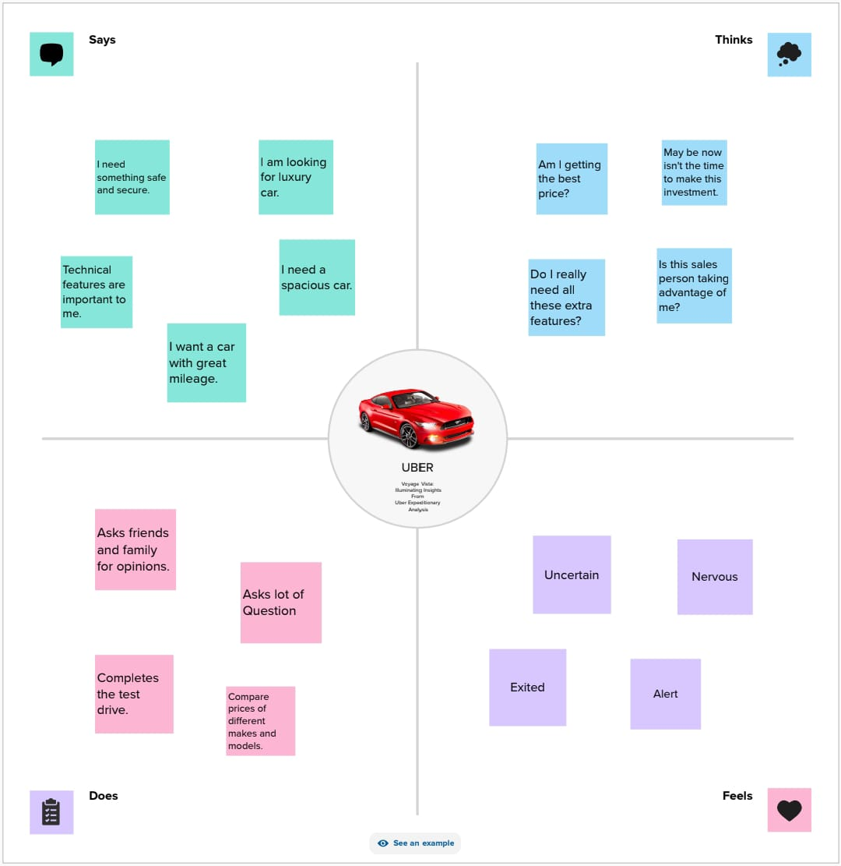

**2.2 Indeation & Brainstroming Map:**

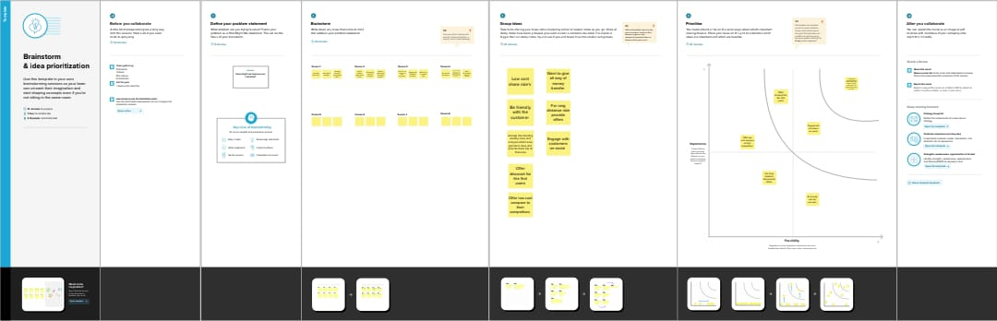

**RESULT:**

Sheet 1

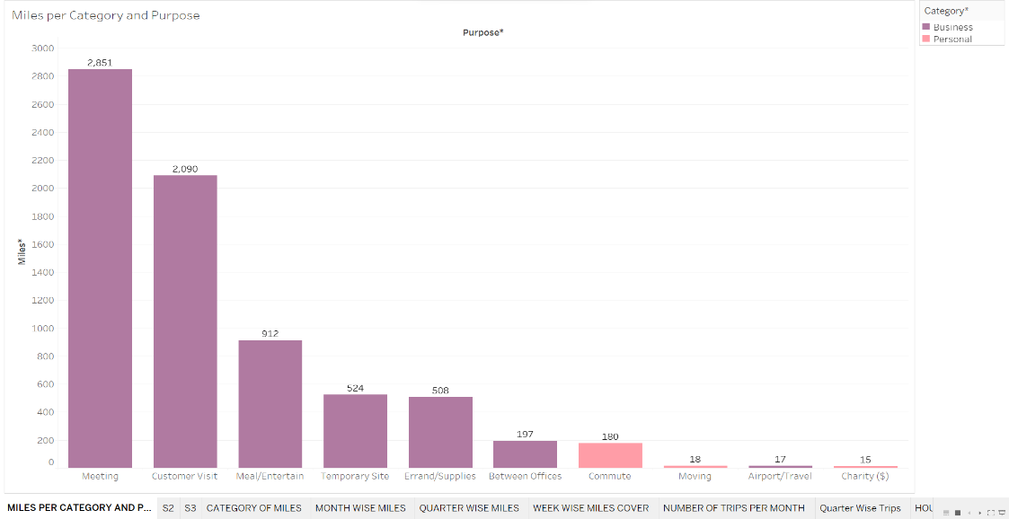

Sheet 2

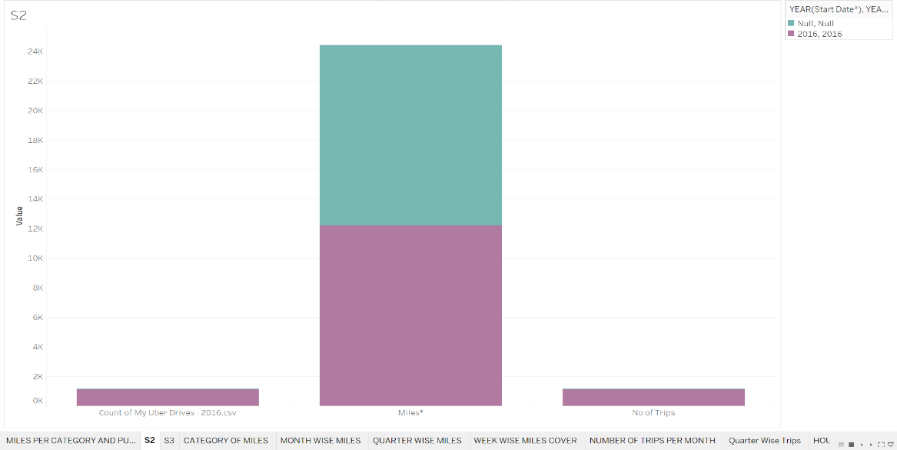

Sheet 3

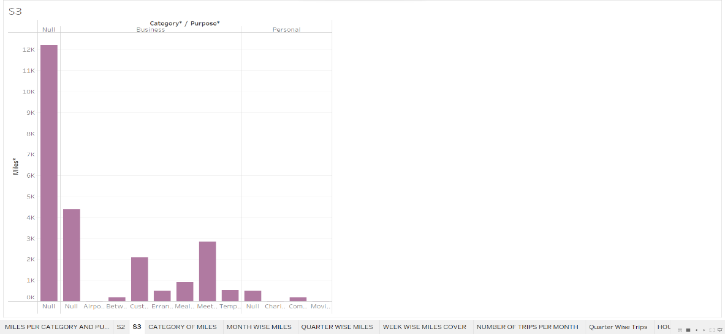

Sheet 4

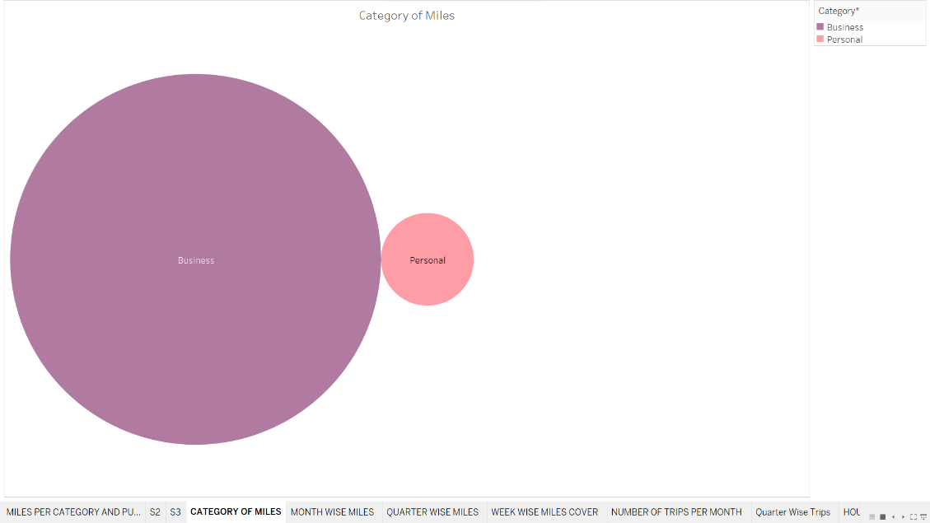

Sheet 5

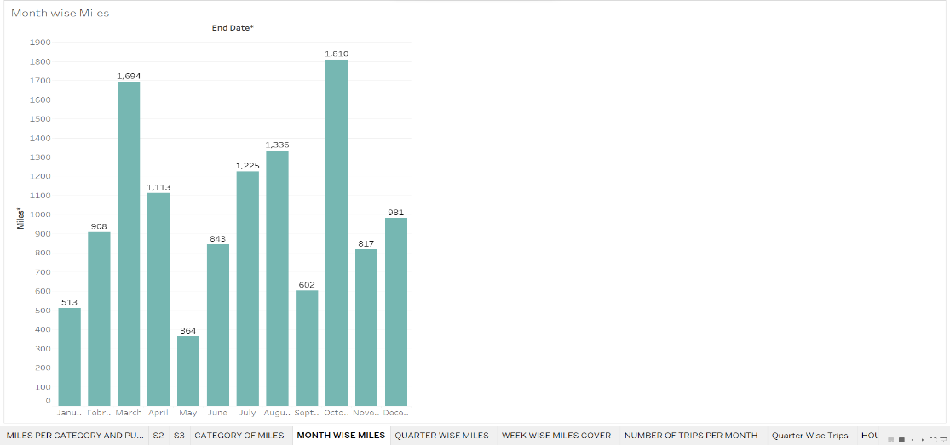

Sheet 6

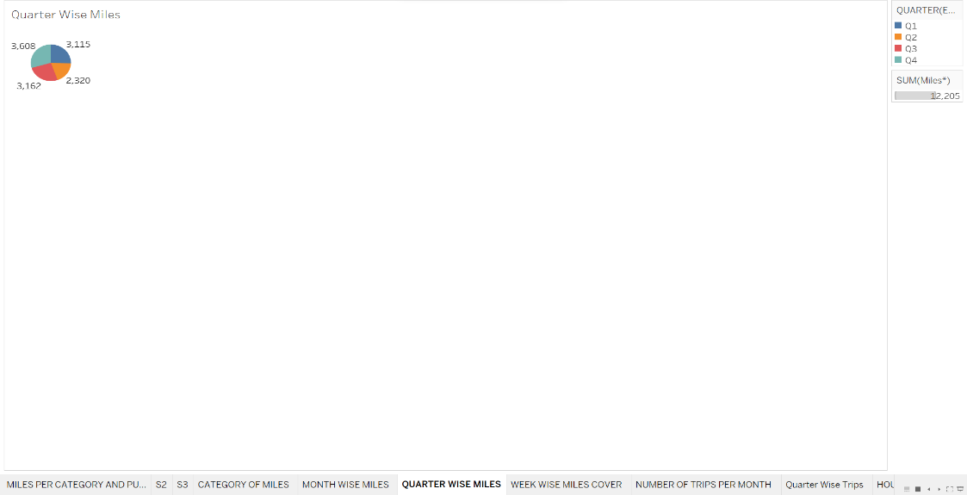

Sheet 7

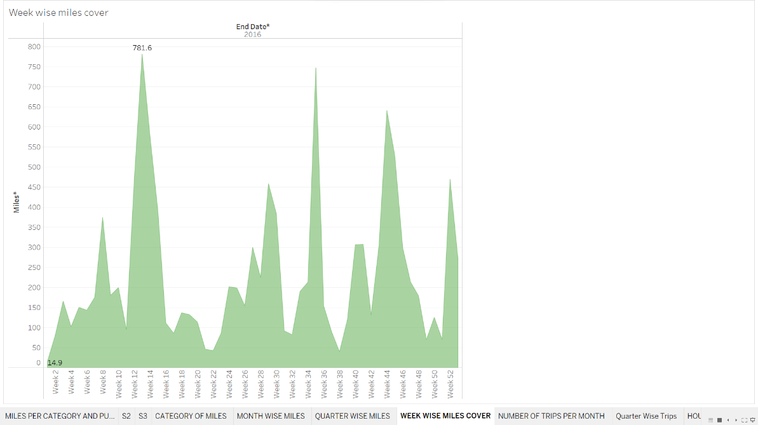

Sheet 8

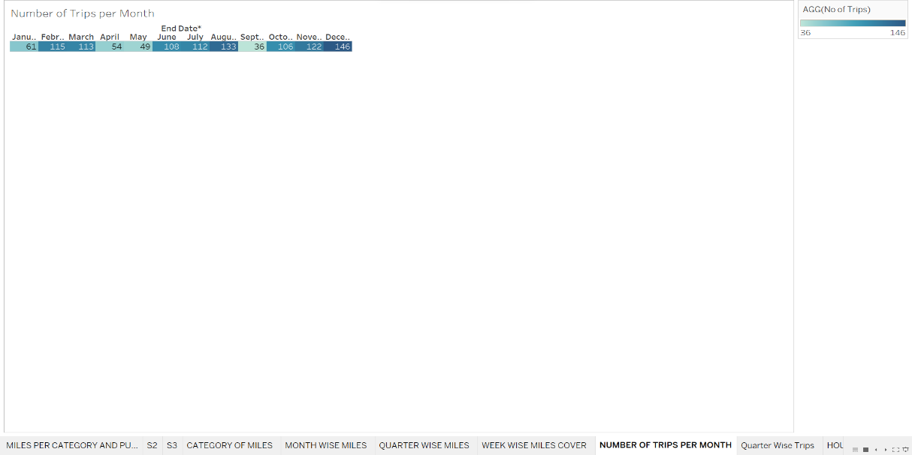

Sheet 9

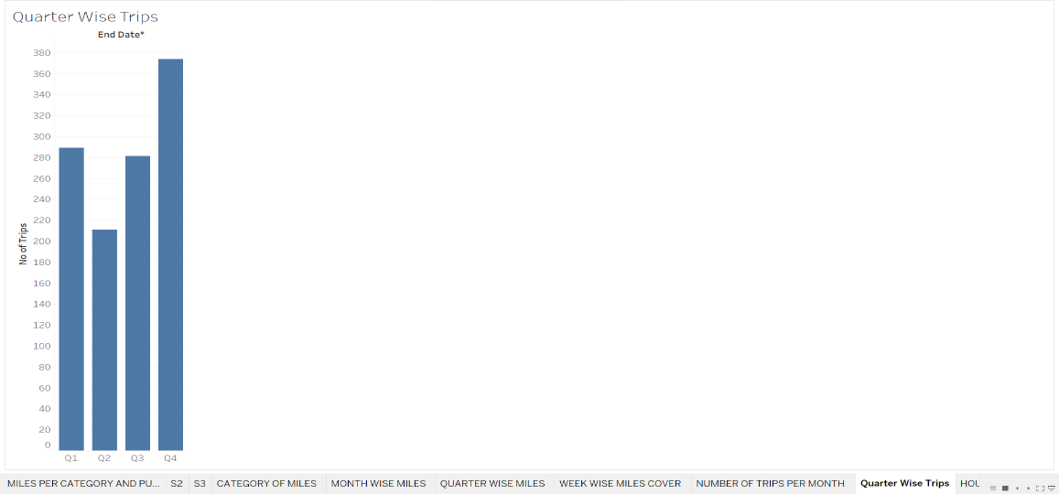

Sheet 10

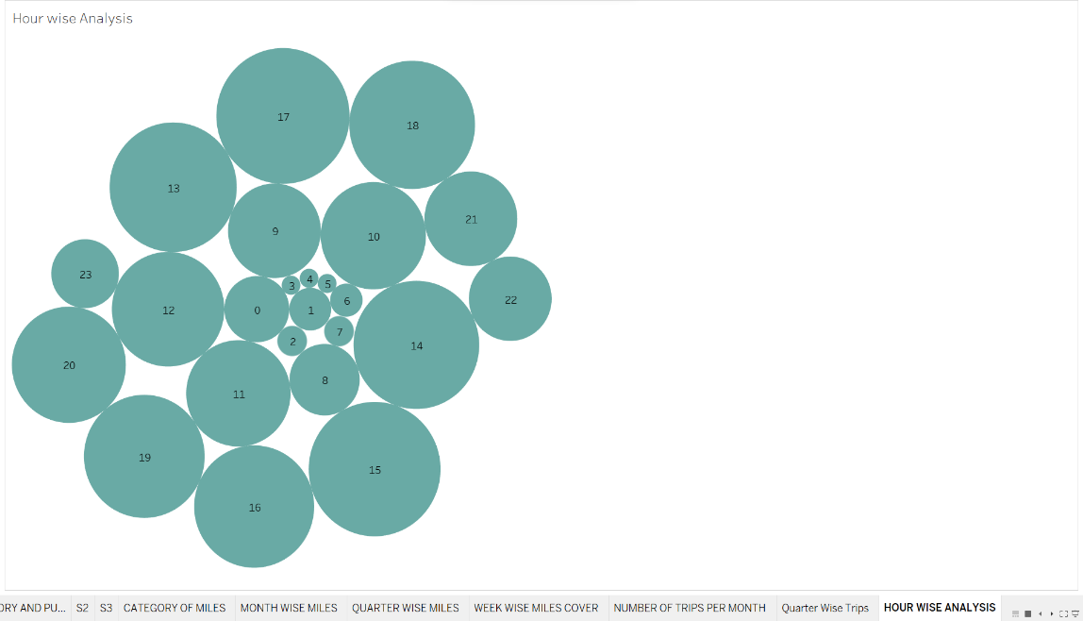

Dashboard 1

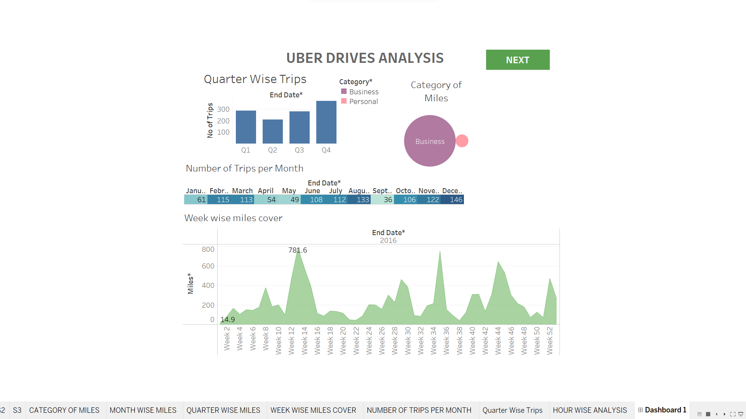

Dashboard 2

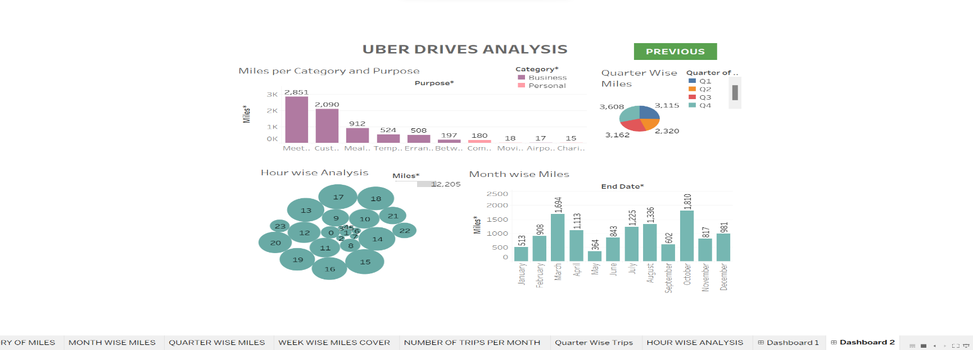

Story

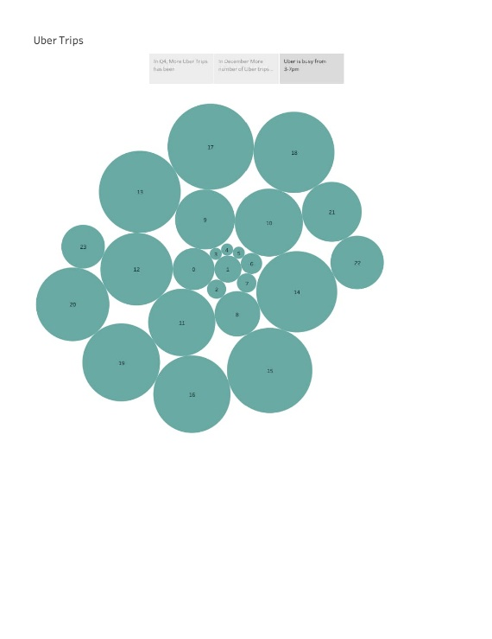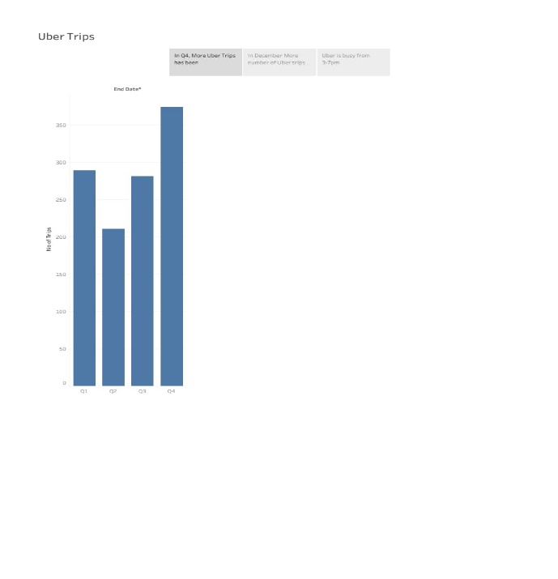

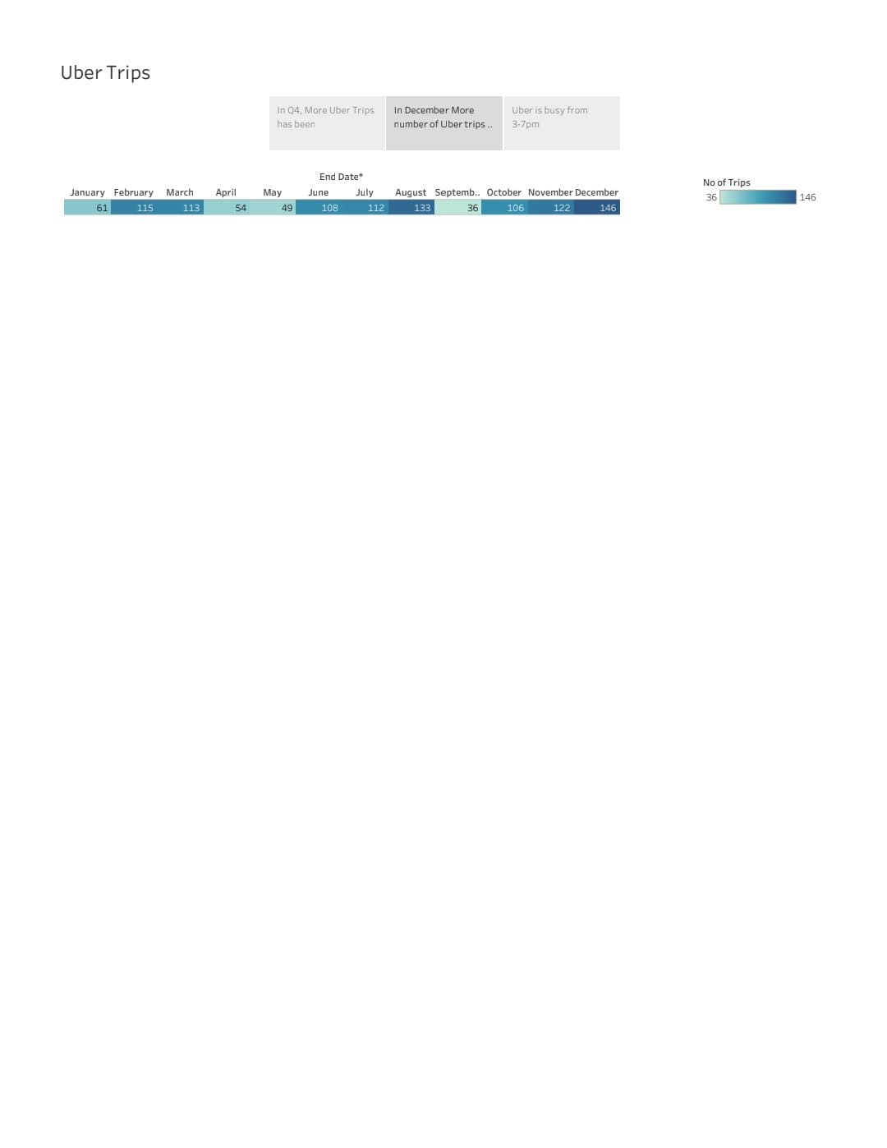

In this we analysis the trips by

1. Bar graph showing Purpose of Uber with Miles covered.

2. Bubble chart showing distribution of Miles with Category.

3. Bar graph showing Quarter with Number of Trips.

4. Highlight Table shows Month with Number of Trips.

5. Bar graph showing Month with Miles.

6. Area Chart showing Week with Miles.

7. Pie chart showing Quarter with Miles.

8. Bubble Chart showing Hour with Number of Trips.

9. Tree Map showing Distance between the Start and Stop Locations.

**Advantage and Disadvantages**:

**Advantage:**

• This analysis can help identify peak hours or days of high demand and optimize driver availability during those times. Trips can be analyzed based on geographic regions or specific cities to identify areas with higher demand.

• In the peak trips area increase the Uber Drives availability.

• Weekly arrange the meeting and discuss about the trips in certain areas.

**Disadvantages:**

• You have a big responsibility for your passengers.

• Taxi drivers don't make much money.

• You don't have a regular schedule.

• Taxi drivers have to work at nighttime.

• Some cab drivers even have to work on weekends and holidays.

• Can be problematic for your family life.

**APPLICATIONS:**

These are used in all the travel companies. By these techniques we can improve the Drives.

In all the travel related works we can use this.

**CONCLUSION:**

Travel Apps Provide Easy Booking. The majority of tourists have smart devices through which they look up places. Having travel apps on a device means that there is no need to visit an agent since all information is readily available on your phone.

Earn anytime, anywhere Fit driving around what matters most. Drive at any time and on any day of the week. You can get an affordable car by the hour, week, or longer. Cars from our vehicle partners come with insurance, unlimited mileage, and more.

**FUTURE SCOPE:**

By improving the business we can give more employment opportunity to the well drivers.

Driving with Uber offers a flexible earning opportunity. It's a great alternative to full-time driver jobs, part-time driver jobs, or other part-time gigs, temp jobs, or seasonal employment. Or maybe you're already a rideshare driver and want to supplement your income by becoming a driver using the Uber platform.

Average earnings (after the Uber fee) of $30-$40 per hour. During special events and weekend nights, drivers sometimes make 25-50% more than that.